Bapuji Educational Association®

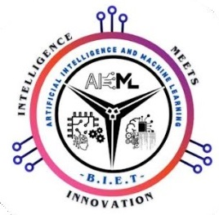



**Bapuji Institute of Engineering and Technology, Davangere – 577 004**

**Department of Artificial Intelligence & Machine Learning (AI&ML)**

**NSS Academic Year 2023-2024 Even Semester**

**Date: 22-07-2024**

**CIRCULAR**

The presentation session of NSS (BNSK459) is scheduled on 05-07-2024, at 9:30 am. All the faculty are informed to note the panel, attend the session and evaluate.

The panel being as follows:

**Panel 1: Venue: B005A**

|  |  |  |
| --- | --- | --- |
| **Sl. No** | **Faculty Name** | **Signature** |
| 1 | Dr. S B Mallikarjuna |  |
| 2 | Dr. Jyothi G C |  |
| 3 | Dr. Amjad Khan |  |
| 4 | Prof. Swetha H U |  |

**Panel 2: Venue: B005B / B.G.L Swamy Seminar Hall**

|  |  |  |
| --- | --- | --- |
| **Sl. No** | **Faculty Name** | **Signature** |
| 1 | Dr. Varsha M |  |
| 2 | Prof. Vijayalakshmi S H |  |
| 3 | Prof. Deepashri K M |  |
| 4 | Prof. Bhagya S G |  |
| 5 | Prof Santhosha P |  |

Dept, Course Co-Ordinators Program Co-Ordinator

(Dept of AI&ML)